Cisco Packet Tracer
Basic Configuration command of switch :
Switch > - it is user mode , normal mode
Switch # - it is privileged mode
Commands :
- enable : change to privileged mode in switch
- exit : to left the mode
- ? : press ? and you will see commands for the current switch mode , it is like manual page , navigate commands
- config terminal :
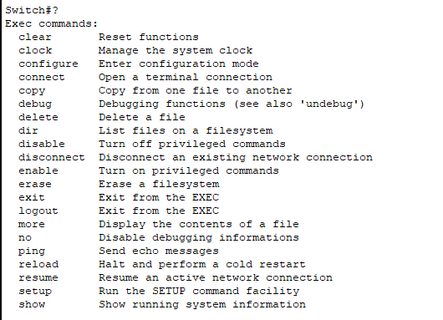
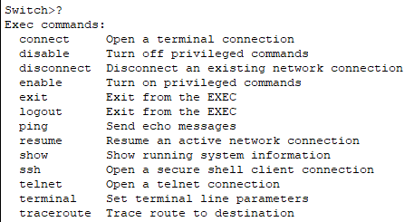

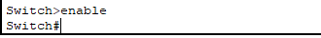

Commands :
- config terminal : change to global config mode
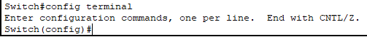
- show privilege : to see the privilege level of current mode
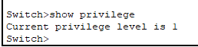
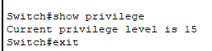

- exit – returned back to lower level mode
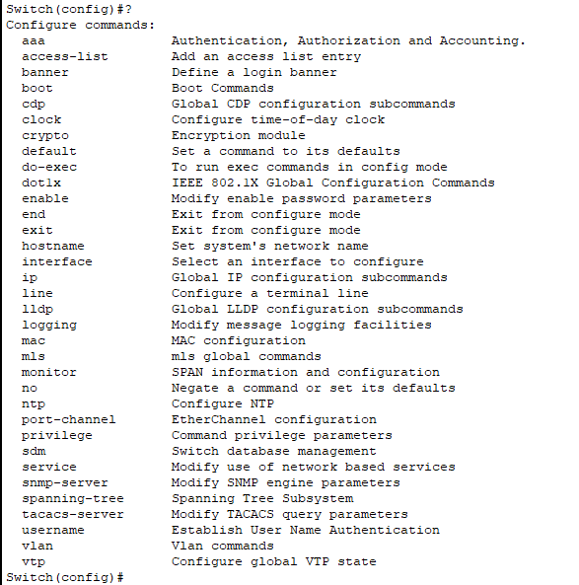
- hostname - set hostname of the switch
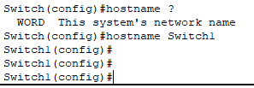

Note: using ? after command can give you hint to complete command , and also we can use command in short form too like Privi of Privilege etc,,
And see that our switch name set to Switch1 , as shown in cli .
Another example :
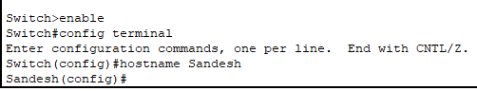
Imp note : While setting up network name each device with it’s ip so that will be easy to navigate through device.
Assigning ip address to a device :
Just click on device and you will see interface choose to Desktop tab
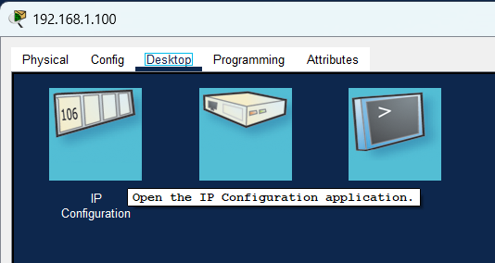
Then select IP Configuration
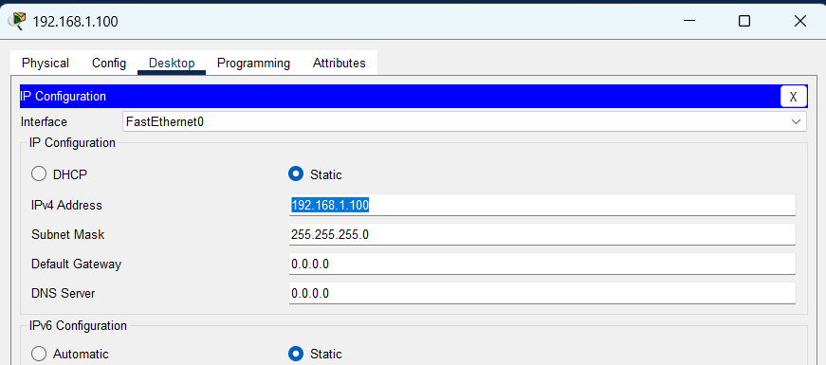
Because it is not a router , we are setting config to static and assign ip in IPv4 section highlighted , hit enter and Subnet Mask will be chosen automatically..
Ping a device on same or different network connected through switch :
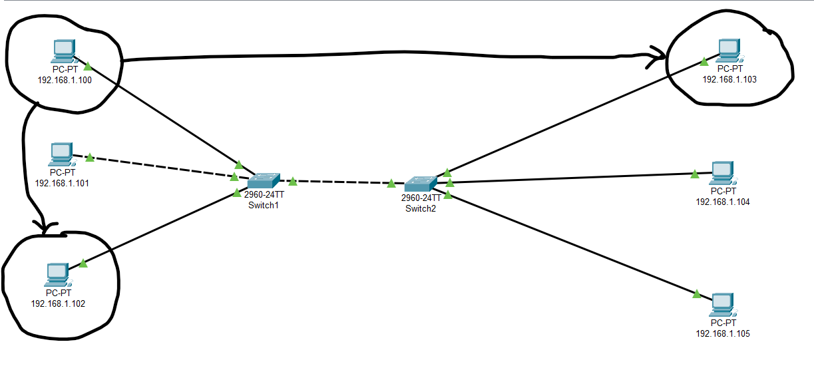
I will ping 192.168.1.102 from 192.168.1.100 which is on a same network, and to 192.168.1.103 located on different network..
Just click on 192.168.1.100 network device and interface will be shown :
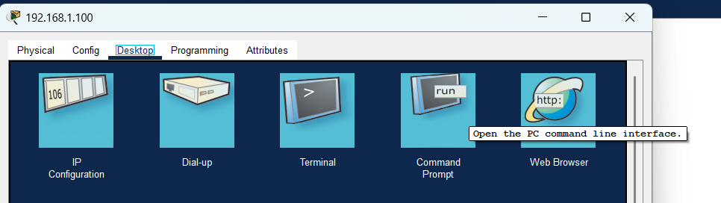
Select on Desktop tab and now select Command Prompt
Command : ping <ip address>
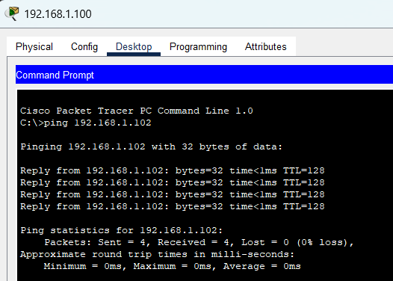
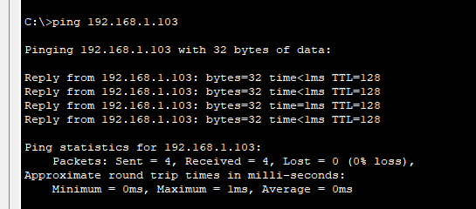

Successfully the sent packets were received without any loss , that’s means connection is reliable and stable.
Command :
banner motd <any message you want to display but should be wrap inside any character that won’t or shouldn’t be in message otherwise message will be end>
---- to display message
Starting screen now :
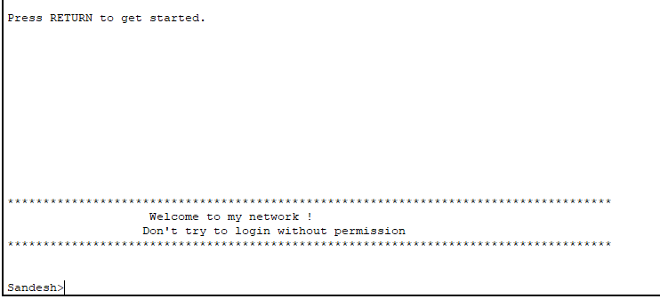
In switch1 :
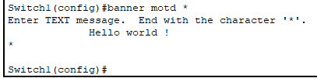

Set login password to switch
line console 0 : switch to enter specific configuration further than global config mode
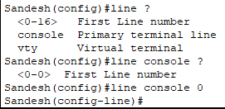
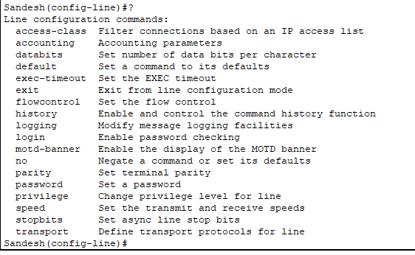
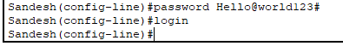
Until now with command :
password <password I want to set>
not successfully set because login command hasn’t been activated
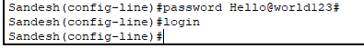
Now it is successfully set, let’s see our welcome screen!
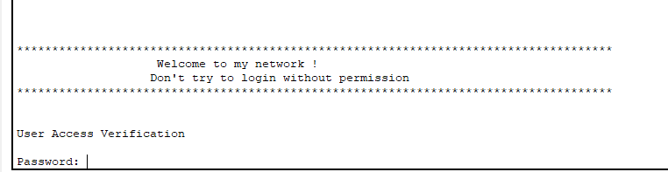

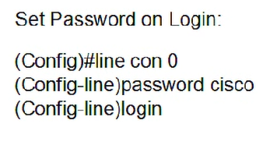
We have seen that we set password on entry level which is during the initial phase of switch , but what if we need level of authority to distribute. If we need someone to get view level permission but not of configuring things in our network. This is called level of authority distribution. We already set password for entry level which is Switch1>, where it got privilege level is 1.
Now what if we need to set password for privileged mode which is Switch1#, where privilege level is 15.
Switch entry level password I have set : Hello@world123#
Switch privileged mode level password : Cisco

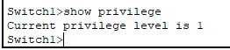
Setting password for privileged mode :
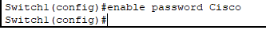
After setting password :
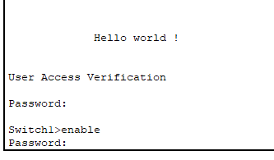

Telnet configuration, VLAN
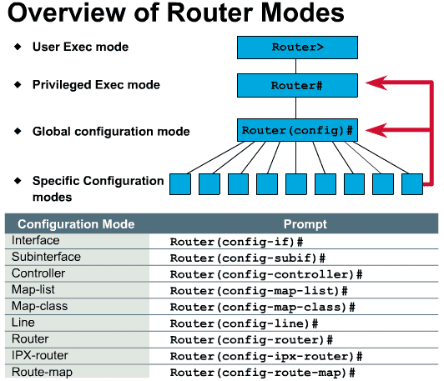
Entering interface mode :
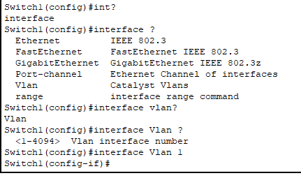
Assigning or adding ip address to Vlan :
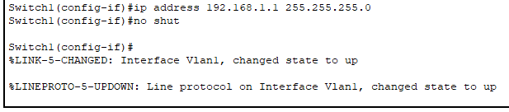
no shut command for enabling it in up condtion, where we manually up it…..

After assigning let’s have a look in Switch1 :
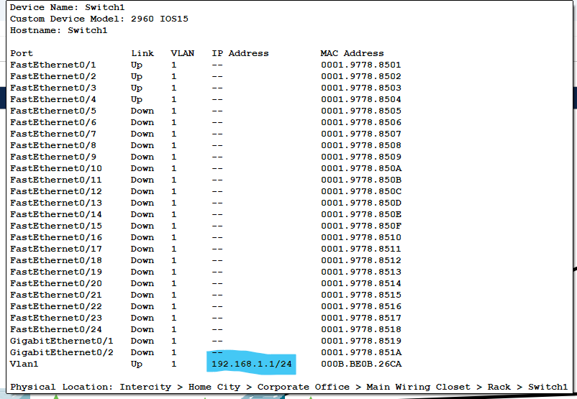
Setting password for telnet 0-15
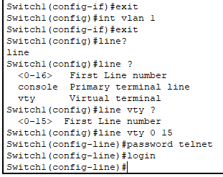
Now accessing telnet from another network device in network ,
in our case let’s do this from device with ip : 192.168.1.100 click on network device and choose Desktop tab :
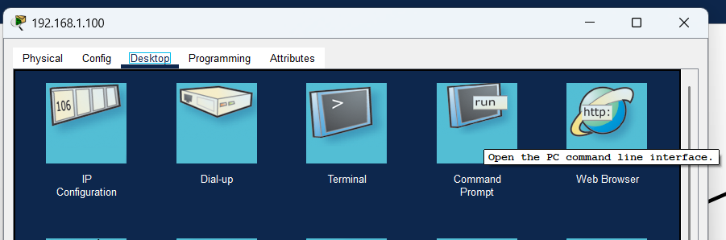
Open Command prompt interface :
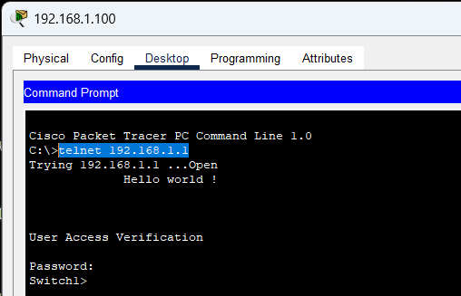
Command : telnet <vlan_ip>
And then enter password your set password for telnet which is : telnet
Now entering privilege mode where we have set password , and then entering global config mode :
Password will use for telnet are :
- telnet password as entry level , when login to telnet
- privilege mode , enable
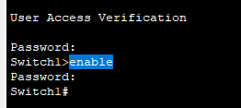
Entering global config mode :
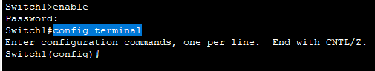

Overall configuration we have practiced :
